PIZZA SALES SQL QUERIES
- KPI’s
- Total Revenue
select sum(total_price) as total_revenue from pizza_sales;
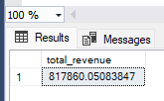

- Average Order Value
select sum(total_price) / Count(Distinct order_id) as [Average Order Value] from pizza_sales;
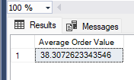

- Total Pizzas Sold
select sum(quantity) as [Total Pizza Sold] from pizza_sales;
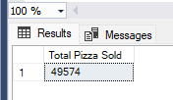

- Total Orders
select count(distinct order_id) as [Total Orders] from pizza_sales;
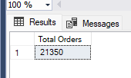

- Average Pizzas Per Order
select cast(cast(sum(quantity) as decimal(10,2))/
cast(count(distinct order_id) as decimal(10,2)) as decimal(10,2)) as [Average Pizza PEr Order] from pizza_sales;
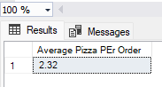

- Chart Requiremnets

- Daily Trends for Total Orders

select DATENAME(DW, order_date) as Order_Day, Count(distinct order_id) as Total_orders
from pizza_sales
Group by DATENAME(DW, order_date);
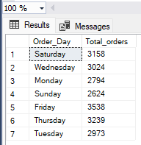

- Monthly Trends for Total Orders
select DATENAME(MONTH,order_date) as Month_name, count(distinct order_id) as Total_orders
from pizza_sales
group by DATENAME(MONTH,order_date)

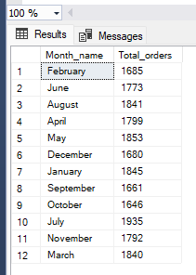

- Hourly Trends for Total Orders:
select DATEPART(Hour, order_time) as Order_hours, Count(distinct order_id) as Total_orders
from pizza_sales
group by DATEPART(Hour, order_time)
order by DATEPART(Hour, order_time)
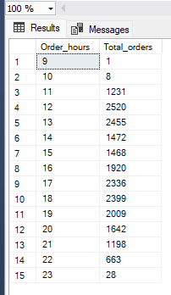

- Percentage of sales by Pizza Category
select pizza_category,sum(total_price) as Total_Sales, sum(total_price)*100 / (select sum(total_price)from pizza_sales) as PCT
from pizza_sales
where MONTH(order_date)=1 --particular ko month ko nikalna
group by pizza_category;
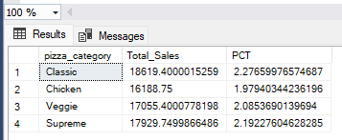

- Percentage of Total Sales by Pizza Size

select pizza_size,cast(sum(total_price) as decimal(10,2)) as Total_Sales,
cast(sum(total_price)*100 / (select sum(total_price)from pizza_sales ) as decimal(10,2)) as PCT
from pizza_sales
group by pizza_size
order by PCT desc;
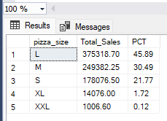

- Total Sales by Pizza Category
Select pizza_category, SUM(quantity) as Total_Sales
from pizza_sales
group by pizza_category;
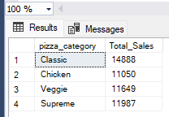

- Top 5 Best Pizza Seller

select top 5 pizza_name, SUM(quantity) as Total_Pizzas_Sold
from pizza_sales
group by pizza_name
order by sum(quantity) desc;
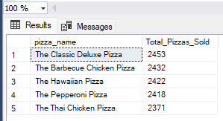

- Top 5 Worse Pizza seller

select top 5 pizza_name, SUM(quantity) as Total_Pizzas_Sold
from pizza_sales
group by pizza_name
order by sum(quantity);
